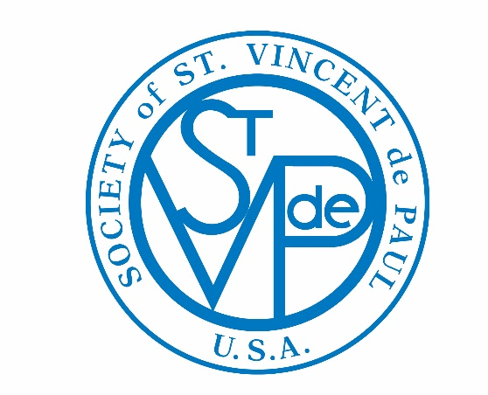
®

Guadalupe Sosa
National Secretary of the United States Society of St. Vincent de Paul
Guadalupe’s time with the Society began when she became a volunteer Vincentian with the Phoenix
Diocesan Council in Arizona. She worked as an employee with the Council for three years, and has
now returned as a Vincentian volunteer.

In 2014, she helped organize the first Spanish Formators’ Formation sponsored by the Phoenix
Council and the Western Region. She was a member of the team on the second Spanish Formation
sponsored by the Contra Costa County Council in California. Guadalupe has taught Ozanam
Formation Experience in Phoenix, and Spanish Ozanam Orientations in Contra Costa. As a
member of the Phoenix Council spirituality and formation committee, she is helping to organize
Spanish Formations.

Guadalupe served as the treasurer for the St. Agnes Conference in Phoenix. In the last two years,
she has helped publish a newsletter for the Western Region SVdP.

Guadalupe has been an active member in her community and church. She served for 14 years as a
Cub Scout leader and was a merit badge counselor with the Grand Canyon Boy Scout Council. She
served on the Diocese of Phoenix Catholic Committee on Scouting and received the Bronze Pelican,
recognition of adults for their Christ-like devotion to youth. She is a proud mother of an Eagle
Scout. She served on the St. Agnes Catholic Church Parish Council, taught religious education and
was certified to teach Safe Environment.

For 19 years, Guadalupe worked as a Senior Policy Advisor with the Arizona State Senate,
Democratic Caucus. Her work involved legislation in the areas of banking, insurance, transportation
and commerce. She conducted Legislature 101 sessions for high school and college students,
community groups and organizations. These were done both in English and Spanish.

Guadalupe received a B.A. in Secondary Business Education from Arizona State University and a
Juris Doctor from the University of California, Hastings College of Law in San Francisco, Calif.
She is a proud native Arizonan and her maternal great-grandmother was born in 1868 in Tucson,
Ariz., making a total of seven generations born and raised in Arizona. She is also proud of her father
who emigrated to the U.S. with the Bracero Program as a 19-year-old from Chihuahua, Mexico.

Guadalupe now lives in Phoenix, but grew up in Queen Creek, Ariz., then a small farming town, and has never lived more than an hour from her hometown.
